Joystick Mapping
Action | Interface device | Specific button thingy
Drive forward/backward | Attack 3 l/r (driver) | sticks
Turbo on | Attack 3 l/r (driver) | triggers
Engage climber | Attack 3 l/r (driver) | Simultaneous l/r press button 2
Shooter on | Extreme 3D Pro (operator) | 9 (middle left base)
Shooter off | Extreme 3D Pro (operator) | 10 (middle right base)
Shoot speed up | Extreme 3D Pro (operator) | 5 (top left of stick)
Shoot speed down | Extreme 3D Pro (operator) | 3 (bottom left of stick)
Shoot angle up | Extreme 3D Pro (operator) | hat
Shoot angle down | Extreme 3D Pro (operator) | hat
Shoot (collector move shooter) | Extreme 3D Pro (operator) | trigger
Collector on | Extreme 3D Pro (operator) | 7 (top left base)
Collector off (hold for reverse) | Extreme 3D Pro (operator) | 8 (top right base)
Engage autoaim | Extreme 3D Pro (operator) | 2 (thumb button)

Diagnostic Groups
- Spiderman drive group
  - Wheel speed
  - Jag voltage, current, temperature
  - Transmission state (engaged/not engaged)
- Shooter group
  - Current wheel speed
  - Current angle
  - Jag voltage, current, temperature
- Collector - TBA
  - Discs held
- Vision group
  - Camera image(s)
  - Dropped frame counter
  - Time lag

Comp Dashboard
Information | Element location | Type of display
Shooter cam | Top left | Video
Climber cam | Top right | Video
Current speed | Right of shooter cam | text
Current angle | Right of shooter cam | text
Calculated speed | Right of shooter cam | text
Calculated angle | Right of shooter cam | text
Calculated point of impact | Overlay on shooter cam | Crosshairs on video
Number of discs held | Under shooter cam | Highlighted circles
(don't) take the shot | Overlay on shooter cam | Color of point of impact
Climber engaged | Under climber cam | Text/color
Vision group | Under shooter cam | Text/color

Diagnostic Dashboard
Information | Element location | Type of display
Camera images | Top left and middle | video
Vision group | Under camera images | text
Shooter group | Top right
Spiderman drive group | Middle left
Collector group | Middle middle
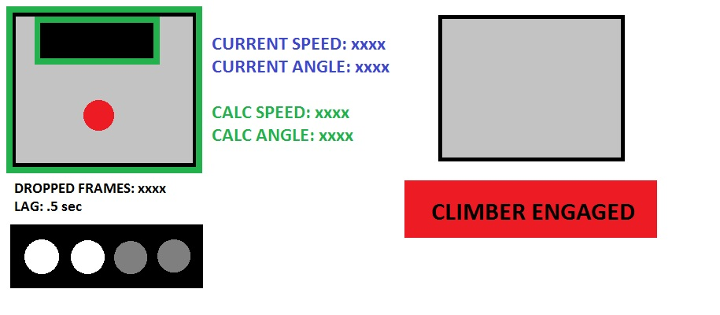
Prototype comp dash – we can definitely make this and the diagnostic dash fancier

